public class Weather {

//@Mandatory

public String country = "Portugal";

//@Mandatory

public String city = "Braga";

public byte[] Serialize() { }

}

public static void main(String[] args) throws IllegalArgumentException, IllegalAccessException, Exception {

long start =System.currentTimeMillis();

Weather w = new Weather();

// w.country="Portugal";

// w.city="Braga";

Message msg = new Message(w);

String msgToSend = msg.Seriliaze();

WebService service = new WebService();

WebServiceSoap port = service .getWebServiceSoap12();

System.out.println(port.getResult(msgToSend));

long end = System.currentTimeMillis();

double time = (double)(end - start);

System.out.println(time);

}

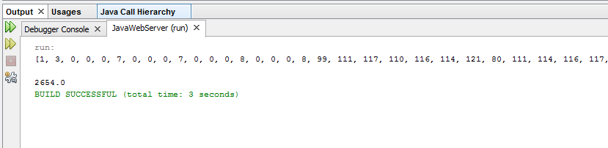

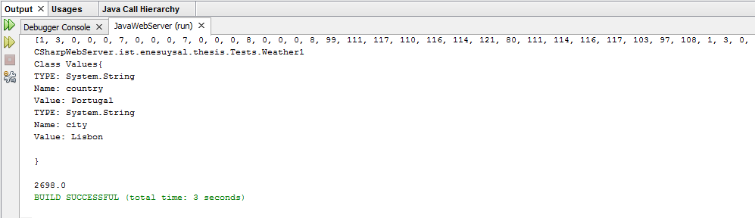

[AvaliableMethod]

public void MakeObjectC(Weather2 test)

{

}

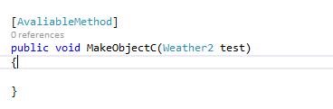

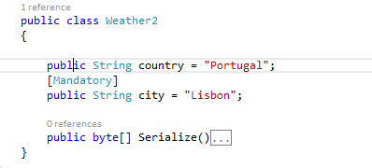

public class Weather2

{

public String country = "Portugal";

[Mandatory]

public String city = "Lisbon";